Allergan–FRANCE PROCESS

Package Name : Allergan_Load_France_Updated.dtsx
Location : PLYSSQL146D
D:\Allergan\SSIS_DEV\Allergan\Allergan.sln

1 The input data is available at TPDATAIN ftp ->/tpdata/Abhay/Allergan/France_SA
2 The received file name is Allergan_with_Retina_YYYYMM.zip.
3 Copy the data to below path at local drive as below
Z:\Allergan\Allergan Data\France\YYYYMM (New Folder) - (only for HUB Team)
And rename it as Alergan_YYYYYMM.zip.
4 The zip file contains below files
Allergan_YYYYMM.csv, Allergan_Brick_structure_ YYYYMM.csv, Allergan_Brick_structure_Retina_ YYYYMM.csv, Allergan_File_Desc.csv, Allergan_Markets_ YYYYMM.csv
5 Allergan_Markets_ YYYYMM.csv contains all the products with factors also. if the process finds new pack, we don’t need ask factors to Allergan, The factors are mentioned already in this file, Screenshot attached for your reference.
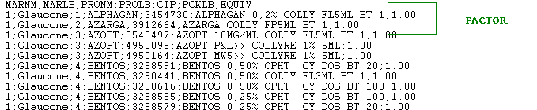

6 Upload this Alergan_YYYYYMM.zip to GDC server at path /Ftpadmin/France
7 We are not processing France on Production server, so we need to copy this zip file to Development server, there is no direct transfer from our local machine to development server FTP, so that we are copying the file to Production server and then transfer the file to development server.
8 The zip file is placed in this path now D:\FTP\France at Production server; we need to copy this zip file to D:\Allergan\Data\France at Production server, these above activities will be happened in Production server.
9 Now open development server, open the path as \\plyssql147p\Allergan\Data\France in development, you can able to copy the zip file from Production server, then copy to D:\FTP\France in development server.
Now zip file is ready at FTP in Development server
10. Open Integration services as per below screenshot in development server
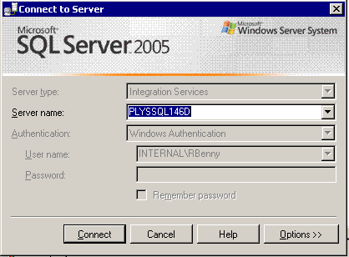

11 Run package for France
Note: France has two packages,
1. Allergan_Load_France - Old Version (not used)
2. Allergan_Load_France_CSV – Current Package for our process
Screenshot attached for your reference.

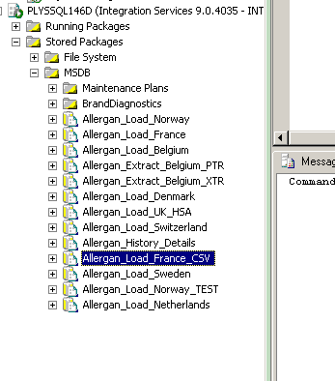

12 Once the process is completed, the output files will be available at /Ftpadmin/Allergan_Production_Output in Development server.
13 Three files will be available as below
France_Data_Load_Product.txt
France_RSA.csv
FranceSummary.txt

14 No need to run any renaming process, while making the delivery to Allergan, we will change the file name as per production month; these activities will be happened in our local machine.

15 We need to copy these 3 files to our local machine, again we don’t have direct access to our local folders, we need to transfer to Production server (GDC server) and then to our local folders.
16 Since the size of the three output files are more, we need to zip the files like France_RSA_YYYYMM.zip, this output Zip file has to copied to the below location
D:\FTP\Allergan_Production_Output ----- >\\plyssql147p\Allergan\Data\France

17 Now the Output zip is placed at GDC server (Production server), we need to copy the zip file to another location in Production server, the path change is mentioned below
D:\Allergan\Data\France (Production server) ---→ D:\FTP\France (Production server)
18 Now we can use our ftp to get access with GDC server and transfer the file (ZIP file) to our local folders, once copied, we can unzip the files and do our Quality checks.

19 If the process is failed
The tables to be used for checking
Product_Pack_Code_Allergan_France
Allergan_France_Factors
20 check if mail is received for new item error.
21 If new product - run the update process by executing below Stored procedure.
Exec usp_Allergan_New_Item_Update_Product_Pack_FRANCE
22 If the product/pack is new check if the factors are needed, get the factors from Allergan_Markets_YYYYMM file for new item and update it in the tables(mentioned above for your reference)
23 If the description changes occured, check it in the same Allergan_Markets_YYYYMM and update it in the tables.
Important Note on History corrections
No need to run any procedures for History corrections on development server, because France process is already running in development, The system will automatically take the records and stores in subsequent tables, so we can directly open merge tool and generate the corrections file.

